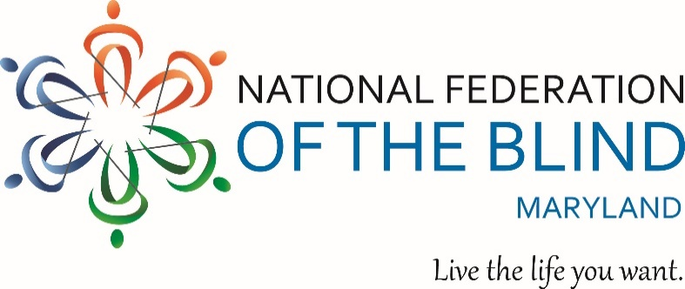
8 TH Annual County Resource Day for Blind & Low Vision Persons
Sponsored By: The National Harbor Chapter, National Federation of the Blind of Maryland
Theme: A New Beginning!
Date: October 7, 2017
Time: 10:00am-2:00pm
Where: Colmar Manor Town Hall
3701 Lawrence Street, Colmar Manor, MD 20722
(Just outside of the D.C. Line from Bladensburg Rd. N.E.)
Admission: Free!
Learn about Assistive Technology, Housing Assistance, Health & Wellness, Financial Stability, Rehabilitation, & more!
Register: To assist us with capacity control, all attendees must pre-register.
1) On-line: http://www.brownpapertickets.com/event/3077960
2) Telephone: 1-800-838-3006
Don’t forget your donations for the Annual Hygiene Kit Project for Homeless Persons.
Contact Chairperson Amber Woods phone: 301-978-6686 Email: woodsamber83@gmail.com for additional information.

